N/A Value

What is N/A Value
# Source: AI Source: Provided by: [Data Path: Persons Table -> ID Column: 1, Name_En Column: Motasem Essam] -> From: [Chatgpt (GPT‑5 Mini)] on [12/10/2025]
N/A stands for “Not Available” or “Not Applicable.”
It is used in data to indicate that a value is missing, unknown, or does not apply to that field.

Meaning of N/A
# Source: AI Source: Provided by: [Data Path: Persons Table -> ID Column: 1, Name_En Column: Motasem Essam] -> From: [Chatgpt (GPT‑5 Mini)] on [12/10/2025]
Situation | Meaning
Not Available | The data exists but was not collected or is missing
Not Applicable | The data does not apply to that record

Examples

Example 1 – Not Available
# Source: AI Source: Provided by: [Data Path: Persons Table -> ID Column: 1, Name_En Column: Motasem Essam] -> From: [Chatgpt (GPT‑5 Mini)] on [12/10/2025]
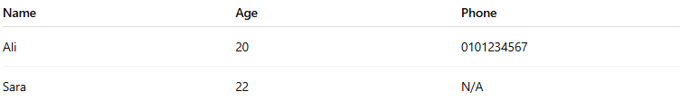
Name | Age | Phone
Ali | 20 | 0101234567
Sara | 22 | N/A
Here N/A means the phone number is not available.

Example 2 – Not Applicable
# Source: AI Source: Provided by: [Data Path: Persons Table -> ID Column: 1, Name_En Column: Motasem Essam] -> From: [Chatgpt (GPT‑5 Mini)] on [12/10/2025]
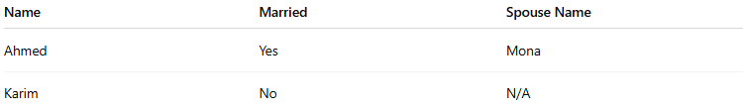
Name | Married | Spouse Name
Ahmed | Yes | Mona
Karim | No | N/A
Here N/A means the field does not apply because Karim is not married.

N/A in Data Analysis
# Source: AI Source: Provided by: [Data Path: Persons Table -> ID Column: 1, Name_En Column: Motasem Essam] -> From: [Chatgpt (GPT‑5 Mini)] on [12/10/2025]
In datasets, N/A values represent missing data.
They must often be handled during data processing by:
- Removing the record
- Filling it with an estimated value
- Leaving it as missing data

Related Terms
# Source: AI Source: Provided by: [Data Path: Persons Table -> ID Column: 1, Name_En Column: Motasem Essam] -> From: [Chatgpt (GPT‑5 Mini)] on [12/10/2025]
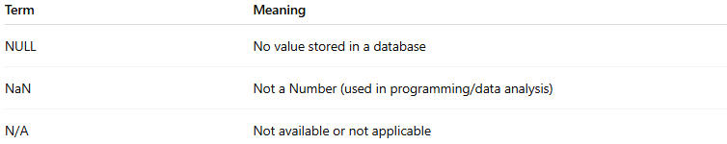
Term | Meaning
NULL | No value stored in a database
NaN | Not a Number (used in programming/data analysis)
N/A | Not available or not applicable

✅ In simple terms:
# Source: AI Source: Provided by: [Data Path: Persons Table -> ID Column: 1, Name_En Column: Motasem Essam] -> From: [Chatgpt (GPT‑5 Mini)] on [12/10/2025]
N/A means the value is missing or does not apply to the data field.

